EXERCISE 6
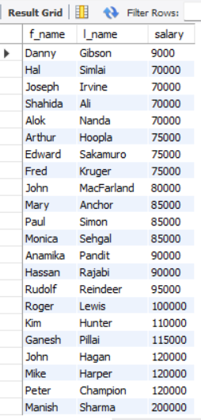
- Order all employees on the basis of the salary they draw.
SELECT f_name, l_name, salary
FROM employee_data
ORDER BY salary ASC;

- List all employees in descending order of their years of service.
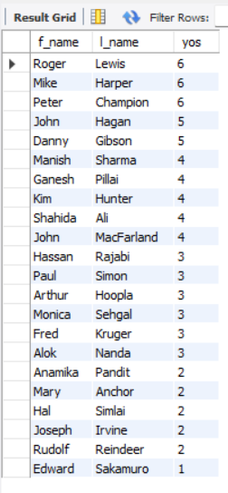
SELECT f_name, l_name, yos
FROM employee_data
ORDER BY yos DESC;

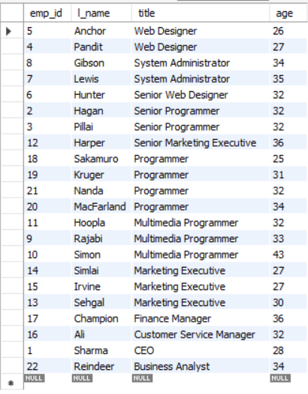
- What does the following statement display? SELECT emp_id, l_name, title, age from employee_data ORDER BY title DESC, age ASC;
SELECT emp_id, l_name, title, age
FROM employee_data
ORDER BY title DESC, age ASC;

- Display employees (last names followed by first names) who hold the title of either "Programmer" or "Web Designer" and sort their last names alphabetically.
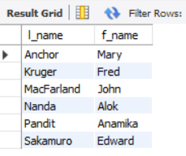
SELECT l_name, f_name
FROM employee_data
WHERE title IN ('Programmer', 'Web Designer')
ORDER BY l_name ASC;

